CS223

Digital Design

Section: 1

Lab-02

Name: Tolga Han Arslan

ID: 22003061

17.10.2022

**b)Circuit schematic for half adder:**

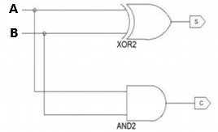

1

3

2

'86

1

3

2

'08

IC List:

1- One 74LS86 quad 2-input XOR gate

2- One 74LS08 quad 2-input AND gate

*74LS86 *74LS08

GND-7 GND-7

+5V-14 +5V-14

**c)Circuit schematic for half subtractor:**

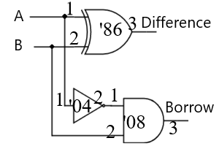

IC List: *74LS86 *74LS08 *74LS04

1-One 74LS86 quad 2-input XOR gate GND-7 GND-7 GND-7

2-One 74LS32 quad 2-input OR gate +5V-14 +5V-14 +5V-14

3-One 74LS04 HEXInverting gate

**d)Circuit schematic for a full adder (using two half adders as black boxes):**

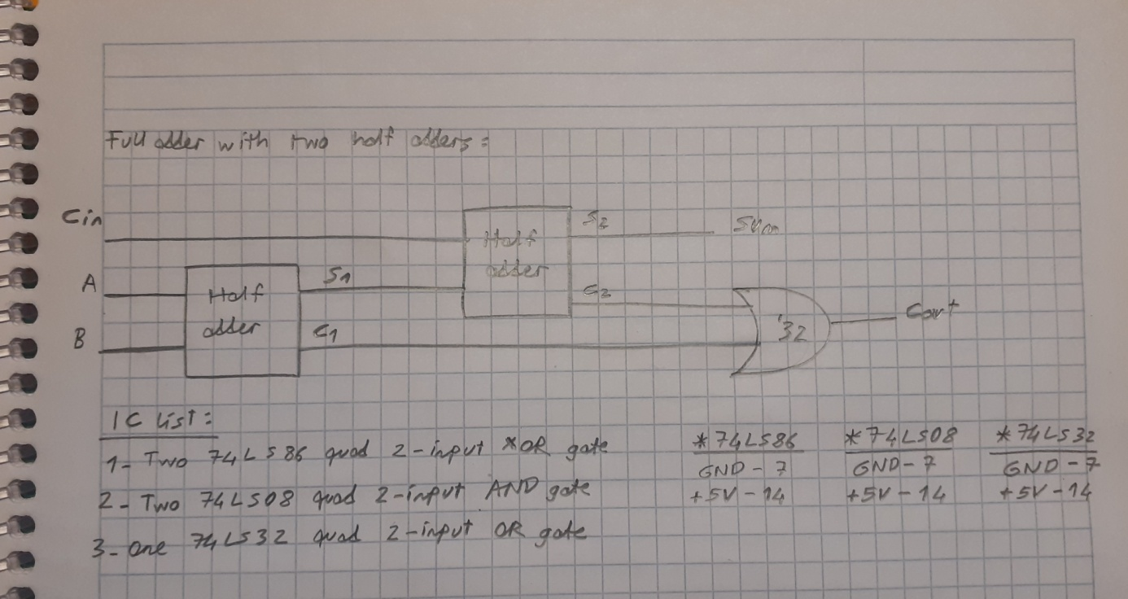

**e)Circuit schematic for a 2-bit adder (using two full adders as black boxes):**

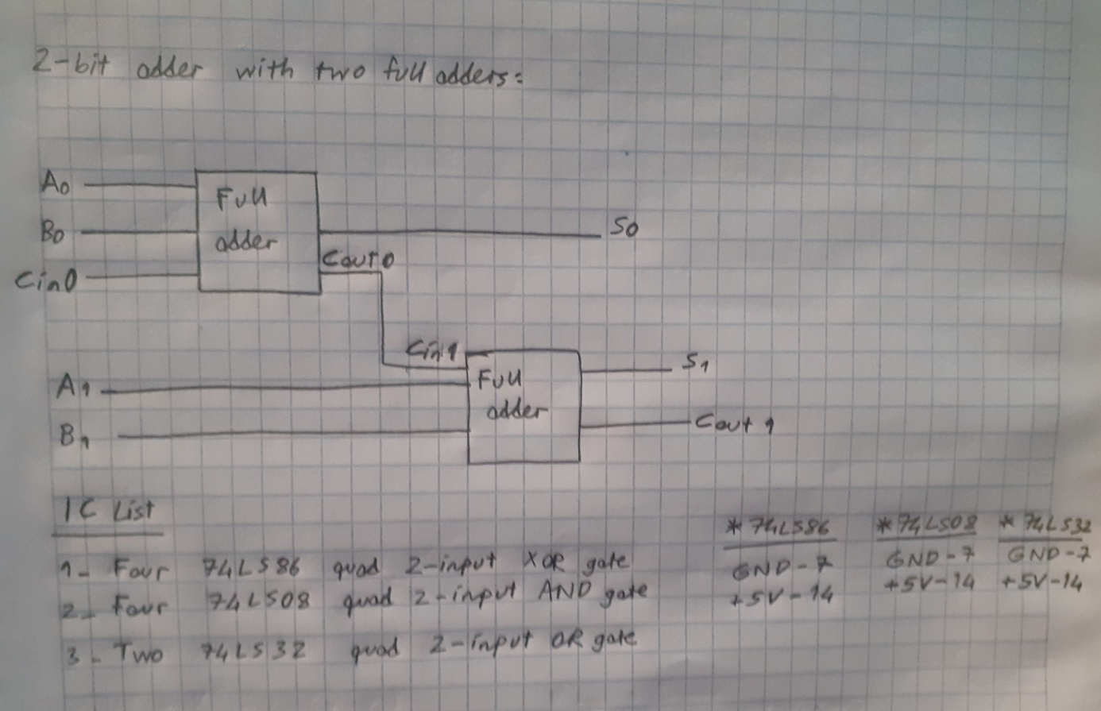

**f)Circuit schematic for the lab calculator (refer Figure 1-2):**



**g)Behavioral SystemVerilog module for the half adder and a testbench for it:**

|  |
| --- |
| module half_adder (input logic a, b, output logic s, c);  assign s = a ^ b;  assign c = a & b;  endmodule |
| module half_adder_testbench();  logic a, b, s, c;  half_adder dut(a, b, s, c);  initial begin  a = 0; b = 0; #10;  b = 1; #10;  a = 1; b = 0; #10;  b = 1; #10;  end  endmodule |

h)**Behavioral SystemVerilog module for the half subtractor and a testbench for it:**

|  |
| --- |
| module half_subtractor( input logic a, b, output logic d, bout);  assign d = a^b;  assign bout = ∼a & b;  endmodule  //testbench module  module half_subtractor_testbench();  logic a, b, d, bout;  half_subtractor dut(a,b,d,bout);  initial begin  a = 0; b = 0; #10;  b = 1; #10;  a = 1; b = 0; #10;  b = 1; #10;  end  endmodule |

**i)Structural SystemVerilog module for the full adder and a testbench for it. Use the half adder module you wrote in part (g):**

|  |
| --- |
| module full_adder(input logic a, b, cin, output logic sum, cout);  /* wire */ logic s1, c1, c2;  half_adder adder1(a,b,s1,c1);  half_adder adder2(cin, s1,sum ,c2);  assign cout = c2 | c1;  endmodule    //testbench  module full_adder_testbench();  logic a,b,cin, sum, cout;  full_adder dut(a,b,cin,sum,cout);  initial begin  a=0; b=0; cin=0; #10;  cin=1; #10  b=1; cin=0; #10;  cin=1; #10;  a=1; b=0; cin=0; #10;  cin = 1; #10;  b=1; cin=0; #10;  cin=1; #10;  end  endmodule |

**j)Structural SystemVerilog module for the 2-bit adder and a testbench for it. Use the full adder module you wrote in part (i): // partial testbench**

|  |
| --- |
| module two_bit_adder(input logic a[1:0], b[1:0], cin, output logic s[1:0], cout);  logic cin1;  full_adder adder1(a[0], b[0], cin, s[0], cin1);  full_adder adder2(a[1], b[1], cin1, s[1], cout);  endmodule  //testbench  module two_bit_adder_testbench();  logic a[1:0], b[1:0], cin, s[1:0], cout;  two_bit_adder dut(a[1:0],b[1:0],cin,s[1:0],cout);  initial begin  a[0]=0; a[1]=0; b[0]=0; b[1]=0; cin=0; #10;  a[0] = 1; #10;  a[0] = 0; a[1] = 1; #10;  a[0] = 1; a[1] = 0; b[0] = 1; #10;  a[0] = 0; a[1] =1; b[0] = 0; b[1] = 1; #10;  b[1] = 0; cin = 1; #10;  a[0] = 1; b[0] = 1; b[1] = 0; #10;  a[1] = 1; b[1] = 1; #10;  end  endmodule |

**k)Structural SystemVerilog module for the lab calculator and a testbench for it. (Use your half-adder, and half subtractor as the building blocks for your highest level module):**

|  |
| --- |
| module lab_calculator(input logic a,b,c,d, output logic y,z);  assign y = (a^b) & ~c&~d | ~(a&b) & ~c&d | (a^b) & c&~d | (a^b) & c&d  assign z = (a&b) & c & ~d | (~a&b) &c&d  endmodule  //  xor xor1(a,b,y);  nand nand1(a,b,y);  half_adder adder1(a,b,y,z);  half_subtractor subtractor1(a,b,y,z);  //  module lab_calculator_testbench();  logic a,b,c,d,y,z;  lab_calculator dut(a,b,c,d,y,z);  initial begin  a=0; b=0; c=0; d=0; #10;  b=1; #10;  a=1; b=0; #10;  b=1; #10;  a=0; b=0; d=1; #10;  b=1; #10;  b=0; a=1; #10;  b=1; #10;  a=0; b=0; d=0; c=1; #10;  b=1; #10;  a=1; b=0; #10;  b=1; #10;  d=1; a=0; b=0; #10;  b=1; #10;  a=1; b=0; #10;  b=1; #10; |